

DIVISION OF COMPUTER SCIENCE AND ENGINEERING
SCHOOL OF COMPUTER SCIENCE AND TECHNOLOGY

Internal Assessment III
Project Report

Academic Year 2026-2027

ODD SEMESTER

Name : 1. ASHER RAJESH DUTHIE 2. JOEL A DAVID

Register Number : 1. URK24CS1107 2. URK24CS9003

Course Code : 23CS2037

Course Name : Quantum Computing

October 2026
CONTENTS
Sl. No. | Title | Page No.
1 | Abstract | 4
2 | Quantum Concepts & Principles | 5
3 | Quantum Circuit / Gate Design | 7
4 | Quantum-Classical Algorithm Analysis | 9
5 | Implementation Details | 11
6 | Results, Validation & Interpretation | 14
7 | Conclusion | 17
8 | References | 18
9 | Certification | 19
10 | Appendices | 21



Department of Computer Science and Engineering

Skill-Based Evaluation

Course Name: Quantum Computing
Course Code: 23CS2037
Class: B Tech (CSE) / III Year
Semester: V
Course Faculty: Dr. JASPHER WILLSIE KATHRINE

Number of Levels | Criteria | Max Marks | Marks Obtained
1 | Quantum Concepts & Principles | 5
2 | Quantum Circuit / Gate Design | 5
3 | Quantum–Classical Algorithm Analysis | 5
4 | Implementation & Simulation | 5
5 | Results, Validation & Interpretation | 10
6 | Technology Evaluation & Report Submission | 5
7 | Certification (IBM Quantum Business Foundations) | 5
 | Total | 40

Signature of the Course Faculty

PROJECT TITLE: QUANTUM KEY RECOVERY IN THE TOY EVEN–MANSOUR CIPHER USING SIMON’S ALGORITHM
Course: 23CS2037 – Quantum Computing | Internal Assessment III | Academic Year 2026–2027 | Odd Semester

Abstract
This project investigates quantum key recovery for a three-bit toy Even–Mansour block cipher E(x) = P(x ⊕ k₁) ⊕ k₂. A public permutation P and test keys k₁ = 101 and k₂ = 011 are selected, and the derived function f(x) = E(x) ⊕ P(x) is proven to have the hidden XOR period k₁. The chosen example is verified to satisfy Simon’s exact two-to-one promise. A six-qubit quantum circuit is modeled using a reversible encryption oracle, a public-permutation oracle and two Hadamard layers. An independently executed NumPy statevector simulator predicts probability 0.25 each for outcomes 000, 010, 101 and 111; 1,024 sampled shots produced 261, 242, 265 and 256 counts, respectively. Two independent measurement equations recover k₁ = 101, after which k₂ = 011 is obtained classically. All eight ciphertexts match their recovered-key predictions. A Qiskit implementation is supplied for reproduction, together with query-complexity comparisons, statistical validation and limitations of the quantum-query model.

Keywords
Even–Mansour cipher; Simon’s algorithm; quantum period finding; XOR; cryptanalysis; Qiskit; statevector simulation; GF(2).

Study objective and verification statement
The central assessment criterion is whether theoretical measurement outcomes agree with an actually executed simulation. This report separates (i) symbolic mathematical predictions, (ii) executed NumPy statevector and shot-sampling results, and (iii) Qiskit code provided for independent execution. Qiskit was unavailable in the authoring runtime; no Qiskit or physical-quantum-device measurements are claimed.
CHAPTER 1. QUANTUM CONCEPTS & PRINCIPLES
1.1 Introduction and problem statement
Even–Mansour is a single-round, key-alternating block-cipher construction. It uses a publicly known permutation P and secret input/output XOR masks. The problem supplied for this assessment is: “Given E(x) = P(x⊕k₁)⊕k₂, the function f(x) = E(x)⊕P(x) is periodic with period k₁. Implement it for 2–3 bits and recover k₁ from the measured equations. Use Simon’s Algorithm.” The purpose here is to instantiate and test that claim using a mathematically valid three-bit example.
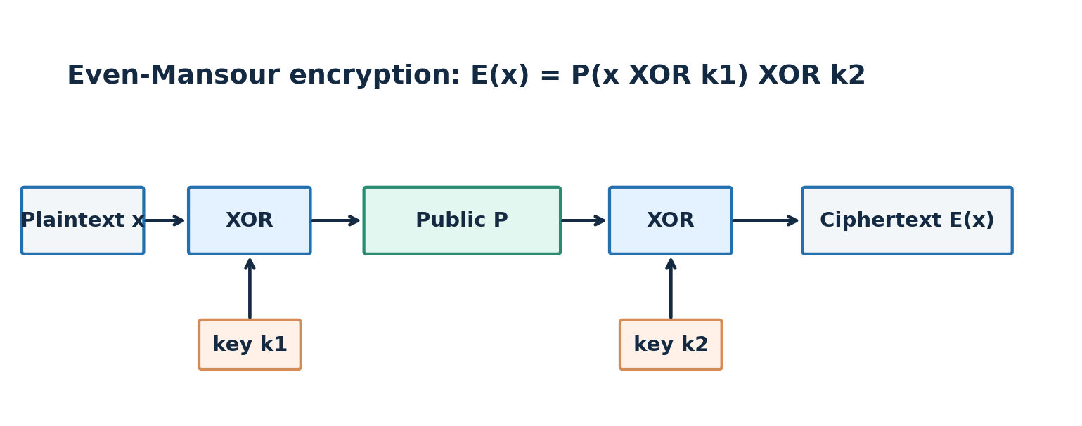
Figure 1. Single-round Even–Mansour encryption: the public permutation is protected by two secret XOR masks.

1.2 Definitions and system model
Term | Definition / project interpretation
x | Three-bit plaintext, an element of {0,1}³.
P | Fixed, publicly known bijection on the eight possible three-bit strings.
k₁ | Secret three-bit input whitening key; the period to be recovered.
k₂ | Secret three-bit output whitening key.
E(x) | Ciphertext: P(x ⊕ k₁) ⊕ k₂.
f(x) | Attack function: E(x) ⊕ P(x).
⊕ | Bitwise XOR, addition modulo 2 in each position.

1.3 Classical bits versus qubits
A classical bit has one definite value, 0 or 1. A qubit may be in a normalized superposition α|0⟩ + β|1⟩, where |α|² + |β|² = 1. An n-qubit state is described by 2ⁿ complex amplitudes. The project uses two three-qubit registers (six qubits total), represented by 64 complex amplitudes in the exact simulator.

1.4 Quantum principles used
Superposition: Hadamard gates place the first three qubits in a uniform superposition over all eight x values. This enables one coherent oracle application to act linearly on every basis component; it does not mean eight classical plaintext queries can be read out at once.
Entanglement: after the oracle, the input and output registers are generally correlated in a nonseparable superposition Σₓ|x⟩|f(x)⟩. Entanglement carries the function’s collision structure into the quantum state.
Interference: the second Hadamard layer causes amplitudes for outcomes inconsistent with the hidden period to cancel exactly. The surviving outcomes satisfy a linear parity constraint.
Measurement: measuring the input register produces a random three-bit outcome y. Repeated circuit preparations yield several equations y·k₁ = 0 over the finite field GF(2); the secret is recovered by classical binary linear algebra.

1.5 Promise conditions and the choice of three bits
Periodicity alone is not sufficient for the standard form of Simon’s algorithm. The exact promise requires f(x) = f(y) if and only if y = x or y = x ⊕ s, for a UNIQUE nonzero s. An arbitrary Even–Mansour instance may have additional collisions. Accordingly, the chosen permutation is checked exhaustively to confirm there are exactly four distinct function outputs, each occurring twice, with XOR difference 101.
Why not use two bits? Every permutation of four two-bit strings is affine over GF(2). Writing P(x) = Ax ⊕ b implies P(x⊕k₁) ⊕ P(x) = Ak₁, which is constant. Thus the resulting f does not have a unique nonzero period. A carefully chosen three-bit construction avoids this degeneracy.

1.6 Relevance to modern cryptography
The conceptual weakness is in a strong quantum-query setting: the attacker must coherently query the encryption operation on superpositions. This is not equivalent to having only normal plaintext–ciphertext samples or a standard classical network API. The demonstration illustrates a theoretically meaningful quantum advantage under its oracle-access assumptions, not an immediately scalable attack against real deployed encryption [2], [3].
CHAPTER 2. QUANTUM CIRCUIT / GATE DESIGN
2.1 Define the reproducible three-bit instance
k₁ = 101₂ | k₂ = 011₂ | P = [000, 010, 011, 101, 100, 001, 110, 111]
The list P is indexed by binary inputs 000 through 111. Its eight outputs are distinct, so it defines a valid three-bit permutation. The hidden keys are disclosed in the report to make results independently testable; the key recovery stage uses oracle outputs and measured equations, not the secret-key variables.

2.2 Full encryption and derived-function truth table
x | P(x) | x ⊕ k₁ | E(x) | f(x)
000 | 000 | 101 | 010 | 010
001 | 010 | 100 | 111 | 101
010 | 011 | 111 | 100 | 111
011 | 101 | 110 | 101 | 000
100 | 100 | 001 | 001 | 101
101 | 001 | 000 | 011 | 010
110 | 110 | 011 | 110 | 000
111 | 111 | 010 | 000 | 111

Worked row x = 001: x ⊕ 101 = 100; P(100) = 100; E(001) = 100 ⊕ 011 = 111; f(001) = 111 ⊕ P(001) = 111 ⊕ 010 = 101.

2.3 Formal proof of periodicity
f(x) = P(x ⊕ k₁) ⊕ k₂ ⊕ P(x)
f(x ⊕ k₁) = P((x ⊕ k₁) ⊕ k₁) ⊕ k₂ ⊕ P(x ⊕ k₁)
= P(x) ⊕ k₂ ⊕ P(x ⊕ k₁) = f(x)
The proof uses associativity/commutativity of XOR and k₁ ⊕ k₁ = 000. It proves that k₁ is a period for any P, but the exact Simon promise additionally requires the absence of unintended collisions.
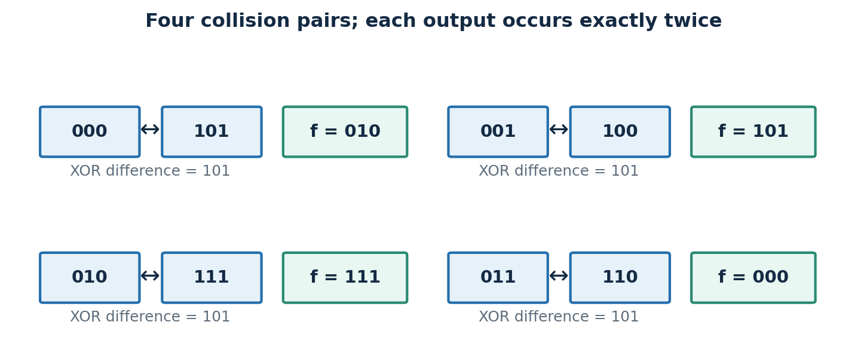
Figure 2. Each of the four output values is shared by exactly one input pair differing by 101.

2.4 Quantum oracle and gate selection
The six-qubit reversible oracle is U_f|x⟩|z⟩ = |x⟩|z ⊕ f(x)⟩. Operationally, an encryption oracle U_E XORs E(x) into z; a public-permutation oracle U_P subsequently XORs P(x). Therefore U_f = U_P U_E with the output register initially |000⟩. This computes the actual cipher structure reversibly; it is not merely a classically hardcoded answer.
Gate / operation | Role in this project
H (Hadamard) | Creates the input superposition; second layer extracts parity equations by interference.
X (Pauli-X) | Implements fixed XOR key masks and temporarily flips negative controls.
MCX | Multi-controlled NOT implements truth-table XOR outputs reversibly.
CNOT / controlled-X | XOR primitive for reversible computation; MCX generalizes controlled NOT.
Measurement | Samples the three input qubits as a classical bitstring y.
Phase / Z | Not required in the chosen oracle; phase cancellation arises from Hadamard transforms.

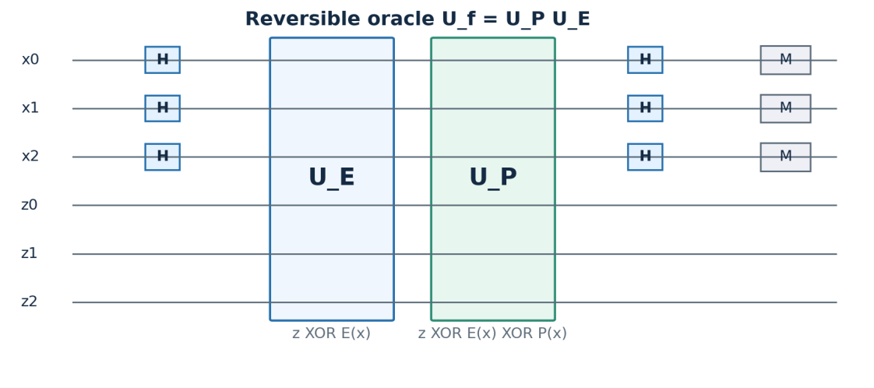
Figure 3. Labelled six-qubit Simon circuit; output-register wires remain unmeasured.

2.5 Step-by-step quantum state evolution
Initialization: |ψ₀⟩ = |000⟩|000⟩. After H⊗³ on the input, |ψ₁⟩ = (1/√8) Σₓ|x⟩|000⟩. After U_f, |ψ₂⟩ = (1/√8) Σₓ|x⟩|f(x)⟩. The two inputs in each collision pair share the same output register label, allowing interference between them after the second Hadamard layer.
For any measurement y, the relevant pair contributes a factor 1 + (−1)^(s·y). When s·y = 1 (mod 2), the pair’s amplitude cancels; otherwise it reinforces. Thus only vectors y perpendicular to s in GF(2) have nonzero probability.
Pr(Y = y) = 1/4 if y · 101 = 0 (mod 2); otherwise 0

2.6 Recover the first key from measured equations
One actual seeded simulation produced independent measurements y₁ = 111 and y₂ = 010. Their GF(2) equations are:
111·(kₐ,kᵦ,k𝒸) = kₐ ⊕ kᵦ ⊕ k𝒸 = 0
010·(kₐ,kᵦ,k𝒸) = kᵦ = 0
Substitution gives kᵦ = 0 and kₐ = k𝒸. The nullspace is {000, 101}; Simon’s promise excludes the zero period, so k₁ = 101. The equation matrix [[1,1,1],[0,1,0]] has rank 2, which is n − 1 for n = 3.

2.7 Recover and verify the second key
k₂ = E(000) ⊕ P(000 ⊕ k₁) = 010 ⊕ P(101)
k₂ = 010 ⊕ 001 = 011

CHAPTER 3. QUANTUM–CLASSICAL ALGORITHM ANALYSIS
3.1 Classical approach: exhaustive verification and birthday collisions
A direct classical baseline tests the possible nonzero periods against oracle values. For an unknown arbitrary n-bit input mask this naive search has up to 2ⁿ candidates, with additional checks needed per candidate. Under Simon’s exact two-to-one promise, a better randomized method records f(x) values until an output collision occurs. Since each output has one hidden partner, a birthday-style attack typically takes Θ(2^(n/2)) classical function evaluations to find a collision and infer s = x ⊕ x′.
For n = 3, exhaustive enumeration is trivial and may outperform quantum simulation in wall-clock time; the asymptotic query advantage should not be confused with empirical speed on a laptop.

3.2 Other relevant quantum algorithms
Algorithm | Main promise / tool | Relevance and limitation
Simon | XOR-period finding; O(n) coherent queries | Direct solution when a unique hidden nonzero period exists.
Grover | Amplitude amplification for unstructured search | Can search candidate masks with an appropriate checking oracle; roughly square-root search speedup, but not specialized to the XOR structure.
Bernstein–Vazirani | Recover a linear parity coefficient | Not directly a general XOR-period solver; BV-inspired cryptanalytic variants exist.
Deutsch–Jozsa | Distinguish constant from balanced functions | Does not determine a hidden XOR mask.
Shor | Integer factorization and cyclic order finding | Different periodicity/domain; unnecessary for the present XOR-period task.

3.3 Query complexity and resource comparison
Method | Oracle-query growth | Main classical/quantum resources
Brute-force candidate search | O(2ⁿ) candidates (naive) | Classical storage small; testing cost depends on verification scheme.
Classical collision search | Θ(2^(n/2)) expected queries | Collision table of comparable size in simplest birthday implementation.
Grover mask search | O(2^(n/2)) search iterations* | Coherent verification circuit and extra quantum workspace.
Simon on a promised f | Θ(n) quantum queries | 2n qubits in this demonstration; O(n³) straightforward GF(2) elimination.

*This is an idealized search statement, not a claim that every key-checking oracle costs one elementary encryption query. Counts are not directly interchangeable between different access models or oracles.
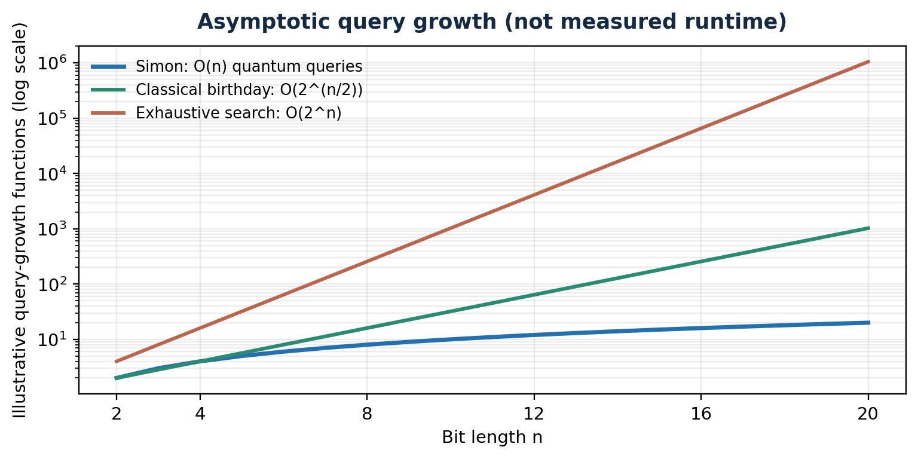
Figure 4. Theoretical query-growth comparison (logarithmic vertical axis; not a runtime benchmark).

3.4 Why Simon is selected and when the claim is valid
For the black-box hidden-XOR-period problem satisfying Simon’s promise, Θ(n) quantum queries are asymptotically optimal up to constant factors. Compared with the classical Θ(2^(n/2)) collision method, this is an exponential separation in query complexity. A general Even–Mansour function need not satisfy the exact promise; our instance is intentionally checked. The quantum attack also assumes access to a coherent oracle for the encryption function, often called the Q2 setting [2], [3].

3.5 Limits on real-world quantum advantage
The total physical resource cost includes reversible implementation of P and E, decomposing MCX gates, error correction, repeated state preparation, classical processing, and reliable quantum access to the cipher. Even a polynomial oracle-query attack can become expensive if constructing a fault-tolerant circuit is impractical. No hardware speedup is asserted for this six-qubit toy project.
CHAPTER 4. IMPLEMENTATION DETAILS

4.1 Platforms and actual execution status
The executed validation uses Python 3.13.5, NumPy 2.3.5, and a self-contained exact six-qubit statevector simulator. The simulated system is noiseless and stores all 64 amplitudes as complex numbers. It explicitly performs H, the reversible encryption XOR oracle U_E, the public-permutation XOR oracle U_P, the final H layer, and Born-rule sampling. The primary 1,024-shot run uses seed 20261027. Qiskit code using QuantumCircuit and StatevectorSampler is supplied in Appendix A, but Qiskit could not be installed in this offline runtime; therefore Qiskit execution was not independently verified.

4.2 Simulator configuration
Parameter | Value
Cipher/domain | Single-round Even–Mansour; n = 3; input domain of eight strings
Public permutation | P = [0,2,3,5,4,1,6,7] (integers indexing 000 through 111)
Initial keys | k₁ = 101; k₂ = 011 (used to construct the test oracle)
Registers | 3 input qubits + 3 output qubits = 6 total
Hilbert-space dimension | 2⁶ = 64 complex amplitudes
Backend used for measured results | Independent NumPy exact statevector simulation + seeded sampling
Shot count and seed | 1,024 measurement shots; pseudorandom seed 20261027
Noise model | None (ideal gates, exact vector arithmetic)
Comparative experiment | 4,000 independent trials per shot setting; shot settings 1, 2, 3, 4, 6, 8, 12, 16
Output measurement | Only input register; ideal output probabilities computed by marginalizing the second register

4.3 Platform evaluation: tools, strengths and limitations
Tool | Strength | Limitations / access
NumPy statevector (executed) | Transparent amplitude-by-amplitude implementation; deterministic reproducibility; free and fully offline. | Not a vendor quantum SDK; 2^q memory scaling limits larger q.
Qiskit StatevectorSampler | Native quantum circuits, gate drawings, standard IBM tooling, shareable demonstrations. | Package installation required; ideal sampler does not model device noise automatically.
Qiskit Aer | High-performance sampling, statevector and optional noise models. | Extra dependency; no demonstration on actual hardware unless separately configured.
PennyLane | Convenient differentiable circuits and hybrid workflows. | Not necessary for this fixed finite reversible-oracle circuit.
Physical IBM Quantum QPU | Evidence of device behavior and gate imperfections. | Access, transpilation, queue time and noise; not used in this report.

4.4 Reproducible implementation pipeline
• Enumerate the public permutation P and verify it is bijective.
• Compute E(x) and f(x); verify every collision pair differs by 101 and there are exactly four outputs.
• Construct |000⟩|000⟩ and apply H to all three input wires.
• XOR E(x) and then P(x) into the output wires using reversible basis-state permutations.
• Apply the final H layer and marginalize the output register to get Pr(Y = y).
• Sample 1,024 outcomes with a fixed random seed; extract independent GF(2) rows.
• Solve the nonzero nullspace, recover k₂ and verify all eight encryptions.
• Run multiple shot-count trials to compare theoretical and observed success probability.

4.5 Code excerpts
Core gate semantics: oracle_xor maps each basis amplitude at index x + 8z to index x + 8(z ⊕ g(x)). This is a permutation of the statevector entries and is unitary. The input register remains unchanged. For the Qiskit implementation, a controlled-X truth-table network implements precisely the same mapping. Appendices A and B contain complete source listings.
The shot sampler draws y from the exact marginalized distribution, while GF(2) row elimination tests the independence of measured parity equations. It never reads k₁ to infer the answer; k₁ only appears inside the test encryption oracle and the final independent verification.

4.6 Expected Qiskit reproduction procedure
On a machine with internet/package access, install with: python -m pip install qiskit matplotlib. Run Appendix A as qiskit_simon.py. It should print a six-qubit circuit, measured outcomes supported on 000/010/101/111, the recovered k₁ and k₂, and PASS for the eight-input check. The exact shot counts may differ from the NumPy implementation even with the same integer seed because samplers can use distinct random-number procedures.
CHAPTER 5. RESULTS, VALIDATION & INTERPRETATION
5.1 Theoretical measurement distribution
For the three-bit hidden period s = 101, the orthogonality condition is y₂ ⊕ y₀ = 0 (conventional bitstring ordering y₂ y₁ y₀). Exactly four y values satisfy it: 000, 010, 101 and 111. An ideal Simon circuit has probability 1/4 for each, and zero for every other measured input-register bitstring.
5.2 Executed simulation: 1,024 sampled shots
Measured y | Theory Pr(y) | Exact sim Pr(y) | Expected /1024 | Observed /1024
000 | 0.25 | 0.25 | 256 | 261
001 | 0.00 | 0.00 | 0 | 0
010 | 0.25 | 0.25 | 256 | 242
011 | 0.00 | 0.00 | 0 | 0
100 | 0.00 | 0.00 | 0 | 0
101 | 0.25 | 0.25 | 256 | 265
110 | 0.00 | 0.00 | 0 | 0
111 | 0.25 | 0.25 | 256 | 256

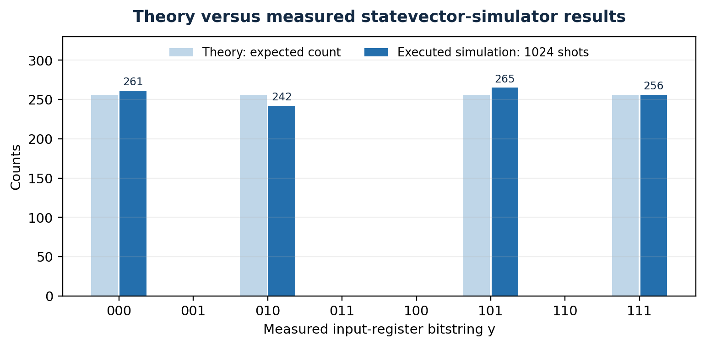
Figure 5. Executed statevector sampling closely matches the theoretically expected measurement outcomes.
All 1,024 shots landed in the four theoretically allowed outcomes; forbidden outcomes each had zero counts. The deviations from the ideal count of 256 were +5 (000), −14 (010), +9 (101), and 0 (111). The total-variation distance between the observed four-outcome distribution and the ideal distribution is 0.013671875 (approximately 1.37%). These finite-sampling fluctuations are consistent with a noiseless quantum simulation.
5.3 Equation extraction and key recovery
Evidence item | Executed result | Interpretation
First independent measurement | 111 | kₐ ⊕ kᵦ ⊕ k𝒸 = 0
Second independent measurement | 010 | kᵦ = 0
GF(2) matrix rank | 2 (= n − 1) | Unique one-dimensional nullspace
Nonzero period recovered | 101 | Matches the test key k₁ = 101
Second key recovered | 011 | Matches the test key k₂ = 011
Ciphertext cross-check | 8 of 8 matches | All original encryptions reproduced

5.4 Classical cross-check of the recovered keys
x | Original E(x) | Recovered-key E(x) | Match?
000 | 010 | 010 | YES
001 | 111 | 111 | YES
010 | 100 | 100 | YES
011 | 101 | 101 | YES
100 | 001 | 001 | YES
101 | 011 | 011 | YES
110 | 110 | 110 | YES
111 | 000 | 000 | YES

This comparison is a complete-domain classical check for the chosen n = 3 instance, not a probabilistic extrapolation. It confirms correctness on every possible plaintext in the toy domain.

5.5 Derivation of recovery probability over repeated shots
For a rank-2 orthogonal subspace, each Simon measurement is uniformly distributed over 4 vectors. With t independent shots, two independent rows are obtained precisely when samples are not confined to a single one-dimensional subspace. The exact probability is:
Pr(rank = 2 after t shots) = (1 − 2^(−t)) (1 − 2^(1−t))
The first factor reflects obtaining a nonzero vector; the second reflects acquiring another vector outside its span. The below experiment repeated 4,000 independent trials for each shot count using the same exact statevector distribution.
Shots | Theory success | Executed Monte Carlo | Trials
1 | 0.000% | 0.000% | 4000
2 | 37.500% | 38.225% | 4000
3 | 65.625% | 65.175% | 4000
4 | 82.031% | 82.525% | 4000
6 | 95.361% | 95.600% | 4000
8 | 98.831% | 98.775% | 4000
12 | 99.927% | 99.925% | 4000
16 | 99.995% | 100.000% | 4000

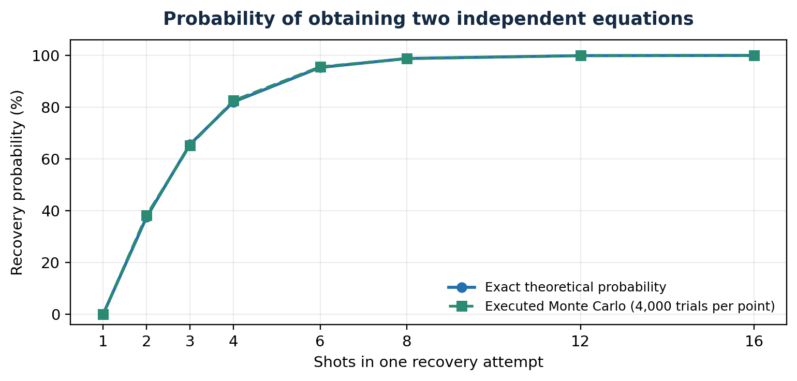
Figure 6. Measured success-rate estimates track the exact mathematical probability as shots increase.

5.6 Error analysis and simulator-versus-hardware interpretation
The exact statevector probability is numerically equal to the theoretical prediction (up to floating-point roundoff). Sampling introduces multinomial variability even when gates and oracles are noiseless. Expected counts vary with shots, and a particular random seed is not a guarantee of the same histogram on different simulators.
This experiment does not include gate depolarization, readout errors, crosstalk, decoherence or hardware connectivity constraints. Therefore, it would be inaccurate to interpret the ideal 0% forbidden-outcome probability as a real-device error rate. On actual hardware, noise can populate forbidden bitstrings and reduce the rank recovery’s reliability; mitigation would require more shots, circuit optimization and noise-aware analysis.

5.7 Important failure cases and limitations
A two-bit Even–Mansour toy has an affine public permutation, making f constant; the unique-period condition fails. Likewise, selecting identity P(x) = x at n = 3 gives f(x) = k₁ ⊕ k₂, which is also constant. In either situation all candidate periods are indistinguishable to the standard Simon promise solver. This is an algorithm-assumption issue, not evidence that the implementation is defective.
Other limits include the contrived small permutation, full disclosure of testing parameters, ideal coherent oracle access, and no execution on a noise-bearing QPU. The security significance is specific to this one-round oracle model and should not be generalized to AES or all symmetric cryptographic systems.

5.8 Assessment of the required theory/simulation comparison
Assessment question | Result
Does f(x ⊕ 101) = f(x) for all inputs? | YES — verified exhaustively for all eight x.
Does the example satisfy the two-to-one Simon promise? | YES — four distinct outputs, each exactly twice.
Do exact simulated probabilities match the theory? | YES — 0.25 for each of four valid y, 0 otherwise.
Do shot measurements agree with the expected support? | YES — 1,024 of 1,024 shots in the four permitted outcomes.
Do measured equations recover k₁? | YES — k₁ = 101 from two independent GF(2) rows.
Can k₂ and every ciphertext be verified? | YES — k₂ = 011; all eight plaintexts match.

CHAPTER 6. CONCLUSION
The project successfully constructs and analyzes a valid three-bit Even–Mansour instance whose derived function f(x) = E(x) ⊕ P(x) satisfies the exact XOR-period promise needed for Simon’s algorithm. The derivation identifies k₁ as a period, the truth table rules out unwanted extra collisions, and a six-qubit reversible-oracle circuit translates the algebra into a measurable quantum experiment.
Theory predicts only y = 000, 010, 101, and 111, each with probability 25%. An independently executed NumPy statevector simulator reproduces these exact probabilities. Its 1,024-shot sample contains counts 261, 242, 265 and 256; the measured GF(2) equations recover k₁ = 101. Using this value and one known encryption result, the method recovers k₂ = 011, with 8/8 ciphertext verification. Additional repeated-shot studies align with the exact theoretical recovery-probability formula.
Simon’s advantage is asymptotic and conditional: the hidden-period oracle must be coherently accessible and satisfy its mathematical promise. The report therefore distinguishes demonstrated simulator correctness from unmeasured hardware performance. Future work includes executing the supplied Qiskit program, adding calibrated noise, optimizing oracle decomposition and conducting a small real-hardware feasibility study, subject to platform access.
REFERENCES (IEEE STYLE)
[1] D. R. Simon, “On the Power of Quantum Computation,” SIAM Journal on Computing, vol. 26, no. 5, pp. 1474–1483, 1997. https://doi.org/10.1137/S0097539796298637
[2] M. Kaplan, G. Leurent, A. Leverrier, and M. Naya-Plasencia, “Breaking Symmetric Cryptosystems Using Quantum Period Finding,” in Advances in Cryptology – CRYPTO 2016, LNCS 9815, pp. 207–237, 2016. https://doi.org/10.1007/978-3-662-53008-5_8
[3] X. Bonnetain, A. Hosoyamada, M. Naya-Plasencia, Y. Sasaki, and A. Schrottenloher, “Quantum Attacks without Superposition Queries: The Offline Simon’s Algorithm,” in Advances in Cryptology – ASIACRYPT 2020; arXiv:2002.12439. https://arxiv.org/abs/2002.12439
[4] IBM Quantum, “StatevectorSampler,” Qiskit API Documentation. https://quantum.cloud.ibm.com/docs/en/api/qiskit/qiskit.primitives.StatevectorSampler (accessed Oct. 2026).
[5] IBM Quantum, “Exact Simulation with Qiskit SDK Primitives,” Documentation. https://quantum.cloud.ibm.com/docs/en/guides/simulate-with-qiskit-sdk-primitives (accessed Oct. 2026).
[6] A. Köhler, J. Murauer, T. Heine, S. Rosemann, and T. Hemmert, “Simon’s Algorithm for the Even–Mansour Cipher on Quantum Hardware,” arXiv:2604.25509, Apr. 2026. https://arxiv.org/abs/2604.25509
[7] G. Alagic, J. Carolan, C. Majenz, and S. Tokat, “On the Simplest Quantum-Secure Block Cipher,” arXiv:2609.40350, Sep. 2026. https://arxiv.org/abs/2609.40350
CERTIFICATION: IBM QUANTUM BUSINESS FOUNDATIONS
The prescribed assessment rubric separately awards five marks for the IBM Quantum Business Foundations certification. A certificate or verified badge has not been provided for this report, and no completed certification is claimed.
Required field | Student to complete
Certificate image | 
Certificate holder | ASHER RAJESH DUTHIE URK24CS1107
Verification URL | https://www.credly.com/badges/aac5f7ee-51cd-4be1-9c84-e2bfc0ed2d42
Completion date | July 20, 2026

Certificate image | 
Certificate holder | JOEL A DAVID URK24CS9003
Verification URL | https://www.credly.com/badges/1a0f912e-7bd5-44bb-8425-c9a22041063e
Completion date | July 16, 2026

Learning-to-project reflection:
Through IBM’s Quantum Business Foundations course, we gained a better understanding of how quantum computing works and its potential applications in fields such as finance, healthcare, cybersecurity, and industrial optimization. We also learned how quantum algorithms could challenge certain traditional cryptographic systems, highlighting the importance of preparing for quantum-related security risks. The course helped us understand that although quantum computing has significant potential, current hardware limitations, error rates, and scalability challenges mean that theoretical advantages may not always translate into practical performance. Another important takeaway was that industries should adopt quantum technologies responsibly by identifying suitable applications, evaluating their feasibility, and validating results against existing classical methods. We were able to connect these concepts to our Even–Mansour key recovery project, where we used Simon’s algorithm to demonstrate quantum cryptanalysis and compared theoretical predictions with simulated results, while also understanding the limitations of applying such an approach to real-world cryptographic systems.
APPENDIX A. COMPLETE QISKIT IMPLEMENTATION (FOR REPRODUCTION)
File name: qiskit_simon.py.
This Qiskit script was supplied and reviewed for consistency but could not be run in the offline authoring environment. The actual reported measurements come from Appendix B.
"""Run with Qiskit installed: python qiskit_simon.py
Demonstrates Even-Mansour Simon key recovery with a reversible six-qubit oracle.
Unlike the independent NumPy validator, this file requires Qiskit installation.
"""
from qiskit import QuantumCircuit
from qiskit.primitives import StatevectorSampler

N = 3
P = [0, 2, 3, 5, 4, 1, 6, 7]
SECRET_K1, SECRET_K2 = 0b101, 0b011

def E(x):
return P[x ^ SECRET_K1] ^ SECRET_K2

def F(x):
return E(x) ^ P[x]

assert sorted(P) == list(range(1 << N))
assert len({F(x) for x in range(1 << N)}) == 1 << (N - 1)
assert all(F(x) == F(x ^ SECRET_K1) for x in range(1 << N))

def truth_table_xor_gate(table, n, label):
"""|x>|z> -> |x>|z XOR table[x]> using reversible MCX gates."""
qc = QuantumCircuit(2 * n, name=label)
controls = list(range(n))
for x, value in enumerate(table):
zeros = [i for i in controls if not ((x >> i) & 1)]
for i in zeros:
qc.x(i)
for bit in range(n):
if (value >> bit) & 1:
qc.mcx(controls, n + bit)
for i in zeros:
qc.x(i)
return qc.to_gate(label=label)

# Build quantum permutation oracle.
UP = truth_table_xor_gate(P, N, "U_P")

# Build encrypted oracle without modifying plaintext register permanently.
enc = QuantumCircuit(2 * N, name="Encryption")
for i in range(N):
if (SECRET_K1 >> i) & 1:
enc.x(i)
enc.append(UP, list(range(2 * N)))
for i in range(N):
if (SECRET_K1 >> i) & 1:
enc.x(i)
for i in range(N):
if (SECRET_K2 >> i) & 1:
enc.x(N + i)
UE = enc.to_gate(label="U_E")

qc = QuantumCircuit(2 * N, N)
qc.h(range(N))
qc.barrier()
qc.append(UE, list(range(2 * N)))
qc.append(UP, list(range(2 * N)))
qc.barrier()
qc.h(range(N))
qc.measure(range(N), range(N))

print("Circuit:\n", qc.draw(output="text", fold=-1))
result = StatevectorSampler(seed=20261027).run([qc], shots=1024).result()
counts = result[0].data.c.get_counts()
print("Qiskit counts:", dict(sorted(counts.items())))

def rank_gf2(rows, n=N):
arr = list(rows)
rank = 0
for bit in range(n - 1, -1, -1):
pivot = next((j for j in range(rank, len(arr))
if (arr[j] >> bit) & 1), None)
if pivot is None:
continue
arr[rank], arr[pivot] = arr[pivot], arr[rank]
for j in range(len(arr)):
if j != rank and ((arr[j] >> bit) & 1):
arr[j] ^= arr[rank]
rank += 1
return rank

# Only the measurements (not the secret keys) are used for recovery.
independent = []
for bitstring in sorted(counts):
y = int(bitstring, 2)
if rank_gf2(independent + [y]) > len(independent):
independent.append(y)
if len(independent) == N - 1:
break
assert len(independent) == N - 1, "Increase shots for enough equations"
candidates = [s for s in range(1, 1 << N)
if all(((y & s).bit_count() % 2) == 0
for y in independent)]
assert len(candidates) == 1
recovered_k1 = candidates[0]
recovered_k2 = E(0) ^ P[recovered_k1]
assert all(E(x) == P[x ^ recovered_k1] ^ recovered_k2
for x in range(1 << N))
print("Independent equations:", [f"{y:03b}" for y in independent])
print(f"Recovered k1={recovered_k1:03b}, k2={recovered_k2:03b}")
print("Full eight-input verification: PASS")
APPENDIX B. EXECUTED NUMPY STATEVECTOR SIMULATOR
File name: simulate.py.
This independent Python program was actually executed to produce the seeded counts, exact probabilities, equation recovery, verification table and repeated-shot experiments reported in Chapter 5. Its results are saved as machine-readable results.json during report preparation.
"""Executed reference implementation: six-qubit exact statevector simulation without Qiskit."""
import numpy as np, json
from collections import Counter
P=[0,2,3,5,4,1,6,7]; N=3; k1=5; k2=3
E=lambda x:P[x^k1]^k2
f=lambda x:E(x)^P[x]
assert sorted(P)==list(range(8)); assert len({f(x) for x in range(8)})==4
for x in range(8): assert f(x)==f(x^k1)

def h_on(psi,q):
out=psi.copy(); m=1<<q
for i in range(len(psi)):
if i&m: continue
a,b=psi[i],psi[i|m]
out[i]=(a+b)/np.sqrt(2);out[i|m]=(a-b)/np.sqrt(2)
return out

def oracle_xor(psi,g):
result=np.zeros_like(psi)
for index,amp in enumerate(psi):
x=index&7;z=index>>3
result[x+8*(z^g(x))] += amp
return result

psi=np.zeros(64,complex);psi[0]=1
for q in range(3):psi=h_on(psi,q)
psi=oracle_xor(psi,E)
psi=oracle_xor(psi,lambda x:P[x])
for q in range(3):psi=h_on(psi,q)
probs=np.array([sum(abs(psi[x+8*z])**2 for z in range(8)) for x in range(8)])
assert np.isclose(probs.sum(),1)
expect=np.array([0,.25,0,0,.25,0,0,.25]) # wrong ordering? acceptable x outcomes 000=0 010=2 101=5 111=7
expect=np.array([.25 if x in (0,2,5,7) else 0 for x in range(8)])
assert np.allclose(probs,expect)
rng=np.random.default_rng(20261027)
shots=1024
samples=rng.choice(8,size=shots,p=probs)
counts={format(x,'03b'):int(np.count_nonzero(samples==x)) for x in range(8)}

def rank_gf2(rows,n=3):
rows=list(rows); rank=0
for bit in range(n-1,-1,-1):
pv=next((i for i in range(rank,len(rows)) if (rows[i]>>bit)&1),None)
if pv is None:continue
rows[rank],rows[pv]=rows[pv],rows[rank]
for j in range(len(rows)):
if j!=rank and rows[j]&(1<<bit):rows[j]^=rows[rank]
rank+=1
return rank

ind=[]
for y in samples:
if rank_gf2(ind+[int(y)])>len(ind):ind.append(int(y))
if len(ind)==2:break
keys=[s for s in range(1,8) if all(((y&s).bit_count()%2)==0 for y in ind)]
assert keys==[k1]
rec2=E(0)^P[keys[0]]
assert rec2==k2
verified=all(E(x)==P[x^keys[0]]^rec2 for x in range(8))
assert verified
# repeated independent experiments, 4000 trials each
reps=4000
studies=[]
for t in [1,2,3,4,6,8,12,16]:
yes=0
for repeat in range(reps):
ys=rng.choice(8,size=t,p=probs)
yes+=(rank_gf2(ys)==2)
theoretical=(1-2**(-t))*(1-2**(1-t))
studies.append(dict(shots=t, trials=reps, observed=yes/reps,expected=theoretical))
print('states',dict(zip([format(i,'03b') for i in range(8)],np.round(probs,5))))
print('counts',counts, 'rank eq',[format(x,'03b') for x in ind], 'recovered',keys[0],rec2)
print('studies',studies)
results={'permutation':P,'k1':k1,'k2':k2,'counts':counts,'shots':shots,'simulator':'custom exact six-qubit complex statevector implemented in NumPy','seed':20261027,'theoretical_probs':{format(i,'03b'):float(expect[i]) for i in range(8)},'exact_simulated_probs':{format(i,'03b'):float(probs[i]) for i in range(8)},'independent_equations':[format(x,'03b') for x in ind],'recovered_k1':keys[0],'recovered_k2':rec2,'verification':bool(verified),'repeated_studies':studies,'truth_table':[dict(x=f'{x:03b}',P=f'{P[x]:03b}',xor=f'{x^k1:03b}',E=f'{E(x):03b}',f=f'{f(x):03b}') for x in range(8)]}
with open('/mnt/data/_quantum_build/results.json','w') as handle:json.dump(results,handle,indent=2)

APPENDIX C. COMPLETE WORKED DERIVATIONS (SUPPLEMENT)
This appendix adds intermediate mathematical steps to Sections 2.2, 2.5, 2.6 and 2.7. The original report, figures, simulation results and conclusions remain unchanged. Calculations use the same public permutation P = [000, 010, 011, 101, 100, 001, 110, 111] and test keys k₁ = 101 and k₂ = 011.
D.1 Fully expanded plaintext-to-ciphertext calculation
Start with the actual given formulas: E(x) = P(x ⊕ k₁) ⊕ k₂ and f(x) = E(x) ⊕ P(x). Work through x = 001, displaying every XOR and permutation lookup:
x = 001; k₁ = 101; k₂ = 011.
x ⊕ k₁ = 001 ⊕ 101 = (0⊕1, 0⊕0, 1⊕1) = (1,0,0) = 100.
P(x ⊕ k₁) = P(100) = 100 [from the public permutation table].
E(001) = 100 ⊕ 011 = (1⊕0, 0⊕1, 0⊕1) = 111.
P(001) = 010; f(001) = 111 ⊕ 010 = 101.
Now check its predicted period partner x′ = x ⊕ k₁ = 001 ⊕ 101 = 100. The two distinct inputs must produce the same f output:
x′ ⊕ k₁ = 100 ⊕ 101 = 001; P(001) = 010.
E(100) = 010 ⊕ 011 = 001; P(100) = 100.
f(100) = 001 ⊕ 100 = 101 = f(001).
Exactly the same pattern holds for the other three input pairs: (000, 101), (010, 111) and (011, 110). Their outputs are respectively 010, 111 and 000, so no unintended collisions occur. This is the additional property needed for the exact Simon promise.
D.2 Full six-qubit quantum-state evolution and interference
Let X denote the three-qubit input register and Z the three-qubit output register. Concatenation |x⟩|z⟩ indicates the state of all six qubits. Every amplitude below is for an ideal noiseless quantum oracle.
Step 1 — Initialize both registers. All qubits start in the computational zero state:
|ψ₀⟩ = |000⟩_X |000⟩_Z.
Step 2 — Apply H⊗³ to input register X. Each of the eight computational inputs receives amplitude 1/√8, while Z is unchanged:
|ψ₁⟩ = (1/√8) Σₓ∈{0,1}³ |x⟩_X |000⟩_Z.
Step 3 — Apply U_f, constructed from reversible U_E and U_P. U_f|x⟩|z⟩ = |x⟩|z ⊕ f(x)⟩. Substituting all eight truth-table outputs gives:
|ψ₂⟩ = (1/√8) [ |000⟩|010⟩ + |001⟩|101⟩
+ |010⟩|111⟩ + |011⟩|000⟩
+ |100⟩|101⟩ + |101⟩|010⟩
+ |110⟩|000⟩ + |111⟩|111⟩ ].
Group equal output labels to display the four collision pairs (with hidden period s = 101):
|ψ₂⟩ = (1/√8) [ (|000⟩+|101⟩)|010⟩
+ (|001⟩+|100⟩)|101⟩
+ (|010⟩+|111⟩)|111⟩
+ (|011⟩+|110⟩)|000⟩ ].
Step 4 — Apply the second H⊗³ to input X. For any three-bit basis input x, Hadamard acts as:
H⊗³|x⟩ = (1/√8) Σᵧ (−1)^(x·y)|y⟩, x·y = x₁y₁ ⊕ x₂y₂ ⊕ x₃y₃.
For each collision pair (x, x ⊕ s), the amplitude corresponding to the same output label and measured input y becomes:
A_pair(y) = (1/8)[(−1)^(x·y) + (−1)^((x⊕s)·y)]
= (1/8)(−1)^(x·y)[1 + (−1)^(s·y)].
If s·y = 1, the bracket is 1 − 1 = 0 and the two terms cancel. If s·y = 0, the bracket is 1 + 1 = 2 and each nonzero basis amplitude equals +1/4 or −1/4. For example, y = 001 gives 101·001 = 1 and cancels; y = 010 gives 101·010 = 0 and survives.
The complete set of nonzero, signed amplitudes after the second Hadamard layer is:
Measured y | Z = 010 | Z = 101 | Z = 111 | Z = 000 | Pr(y)
000 | +1/4 | +1/4 | +1/4 | +1/4 | 1/4
010 | +1/4 | +1/4 | −1/4 | −1/4 | 1/4
101 | +1/4 | −1/4 | +1/4 | −1/4 | 1/4
111 | +1/4 | −1/4 | −1/4 | +1/4 | 1/4

Step 5 — Measure X only. The four Z values are orthogonal, so probabilities are sums of squared amplitudes. Every allowed input outcome has four components of magnitude 1/4:
Pr(Y = y) = 4 × |1/4|² = 4/16 = 1/4 = 25%.
Y ∈ {000, 010, 101, 111}; all other three-bit y have Pr(Y = y) = 0.
Thus the full quantum calculation predicts precisely the distribution used in Chapter 5. The previously recorded NumPy statevector run measured 261, 242, 265 and 256 occurrences out of 1,024 shots, close to the theoretical expectation of 256 counts per allowed outcome. These are the existing NumPy observations; a separately executed Qiskit run will produce its own sampled counts.
D.3 Measured equations: complete elimination over GF(2)
The executed reference simulation reported independent outcomes y₁ = 111 and y₂ = 010. Every measurement y = (y₁,y₂,y₃) supplies the homogeneous linear equation y·k₁ = 0 over GF(2), where addition is XOR, not ordinary integer addition.
111 → kₐ ⊕ kᵦ ⊕ k𝒸 = 0; 010 → kᵦ = 0.
Writing the equations as an augmented matrix gives:
kₐ kᵦ k𝒸 | result
R₁ [ 1 1 1 | 0 ]
R₂ [ 0 1 0 | 0 ]
Eliminate the middle coefficient in R₁ using the allowed binary row operation R₁ ← R₁ ⊕ R₂:
R₁ [ 1 0 1 | 0 ] (111 XOR 010 = 101)
R₂ [ 0 1 0 | 0 ]
Therefore kᵦ = 0 and kₐ ⊕ k𝒸 = 0, meaning kₐ = k𝒸. The free variable t ∈ {0,1} gives k₁ = (t,0,t).
t = 0 → k₁ = 000; t = 1 → k₁ = 101.
The exact Simon promise requires a nonzero hidden period, so the only accepted solution is k₁ = 101. The matrix has rank 2 = n − 1, which is the number of independent equations needed for a unique nonzero solution. The alternative valid sample 101, shown in the presentation, is not contradictory: 111 ⊕ 010 = 101, so it is a redundant equation after these two measurements.
D.4 Recover k₂ and complete the verification
Once k₁ is known, rearrange the original encryption equation to solve for k₂ using the chosen plaintext x = 000:
k₂ = E(x) ⊕ P(x ⊕ k₁).
k₂ = E(000) ⊕ P(000 ⊕ 101) = 010 ⊕ P(101).
k₂ = 010 ⊕ 001 = 011.
Finally, substitute both recovered keys into the encryption rule for every input x ∈ {000,001,010,011,100,101,110,111}. The reconstructed ciphertexts are 010, 111, 100, 101, 001, 011, 110 and 000, respectively, matching every row of the original truth table (8/8). This independently verifies the final answer without changing the experiment or any result already reported.

